NAME:- GANESH DAMODHAR SHITOLE
ROLL NO:- 83583

Assignment 1

1.
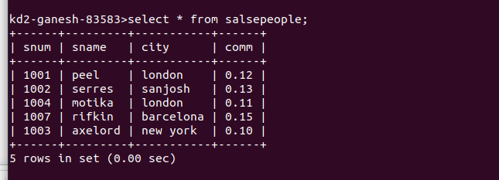
2.
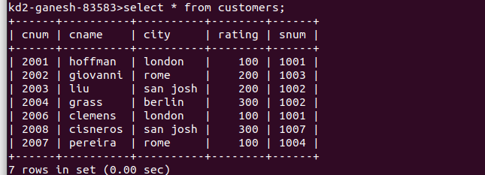
3.
